**7PAM2000 APPLIED DATA SCIENCE 1**

ASSIGNMENT 2 STATISTICS AND TRENDS

NAME: KAMALI BAKTHAVATCHALAM

STUDENT ID: 22081557

This report is focused on 10 key Asian countries. The analysis examined correlation among various factors crucial to climate change and investigated their root causes. i.e., Urban population (%), Arable land (%), Forest area (%), Agricultural land (%), Total greenhouse gas emissions (kt of CO2 equivalent), Access to electricity (%), Renewable electricity output (% of total electricity output), Renewable energy consumption (% of total final energy consumption), Electric power consumption (kWh per capita), Population growth (annual %), Agriculture, forestry, and fishing, value added (% of GDP).

GITHUB LINK [: https://github.com kamalibakthavatchalam/ads1assignment2statistics](NULL)

**Analyzing Climate Change Trends**

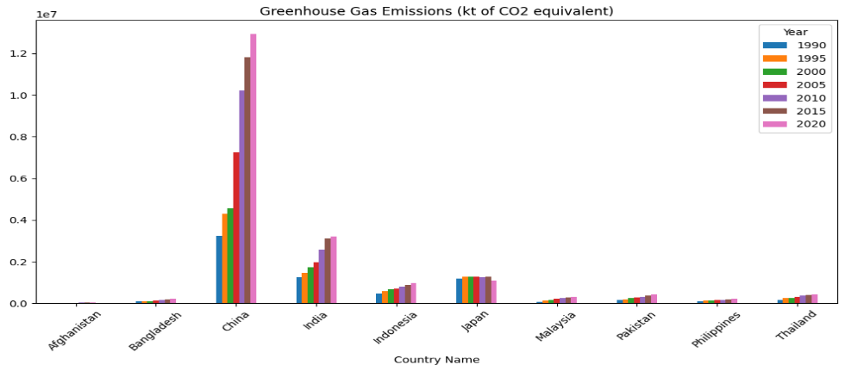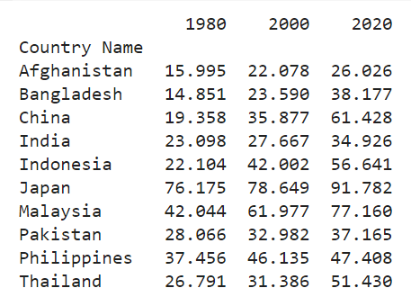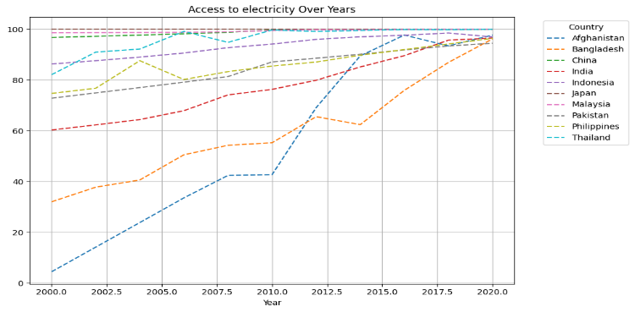

Afghanistan, India, and Bangladesh have shown rapid increases in access to electricity (%) post-2010, possibly driving accelerated urbanization. Conversely, Indonesia's experienced a decline after 2017, potentially due to reduced access to essential services.

The presented bar graph illustrates greenhouse gas emissions across

countries from 1990 to 2020, indicating China as the largest emitter.

India ranks second, with Japan positioned as the third-largest emitter.

Afghanistan is the least emmitter.

The rise in urban populations from last 40 years, notably in countries such as China, Indonesia, and Thailand, signify rapid urbanization. This urban growth correlates with heightened energy consumption, contributing to

increased CO2 emissions.

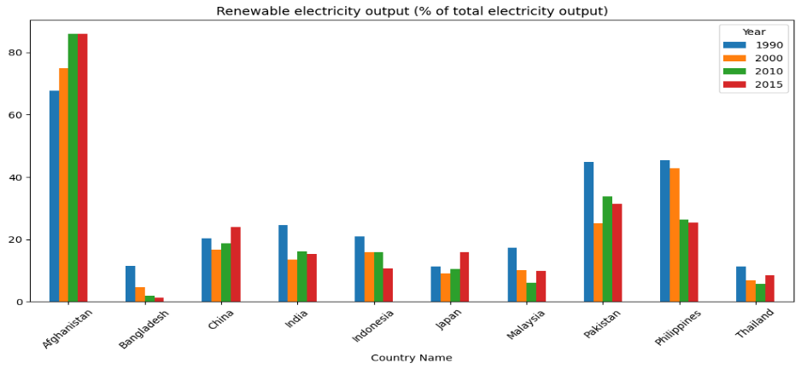

The bar graph show that the Afghanistan has the highest renewable electricity (%), followed by Pakistan and the Philippines. China and India have comparatively lower percentages, indicating a greater reliance on non-renewable energy sources, potentially contributing to higher CO2 emissions due to increased usage of fossil fuels for electricity generation.

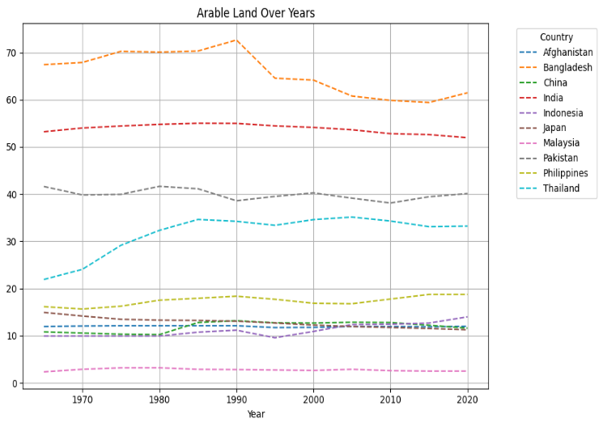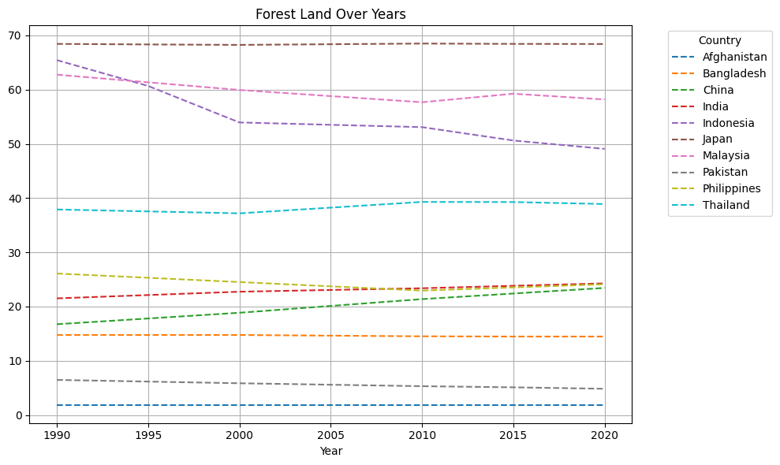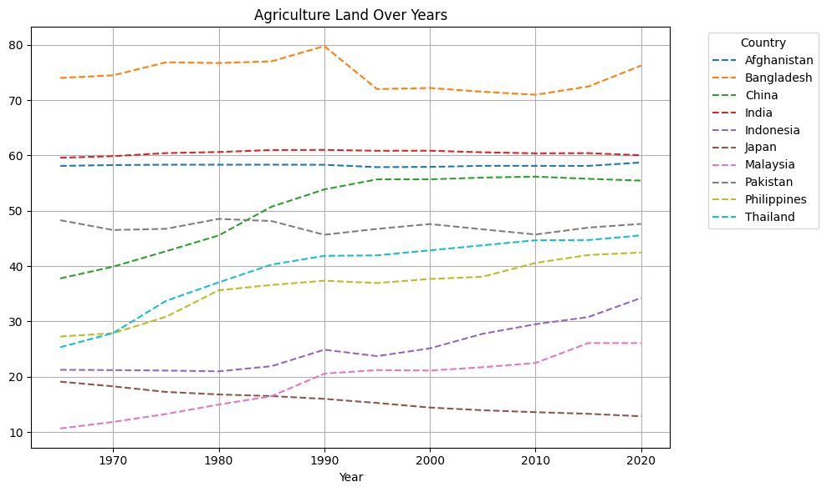

The above plot shows that the urbanization in Bangladesh and India leads to reduced arable land. In Thailand, arable land % increases over the time. Forest land plot reveals that there is a reduction of forest land in Indonesia (reason: Palm oil expansion) leads to deforestation, whereas Japan secures 70% which also controls CO2 emission. China’s agriculture land (%) increases almost 20%, while Japan’s decline due to shortage of farmland, and urbanization.

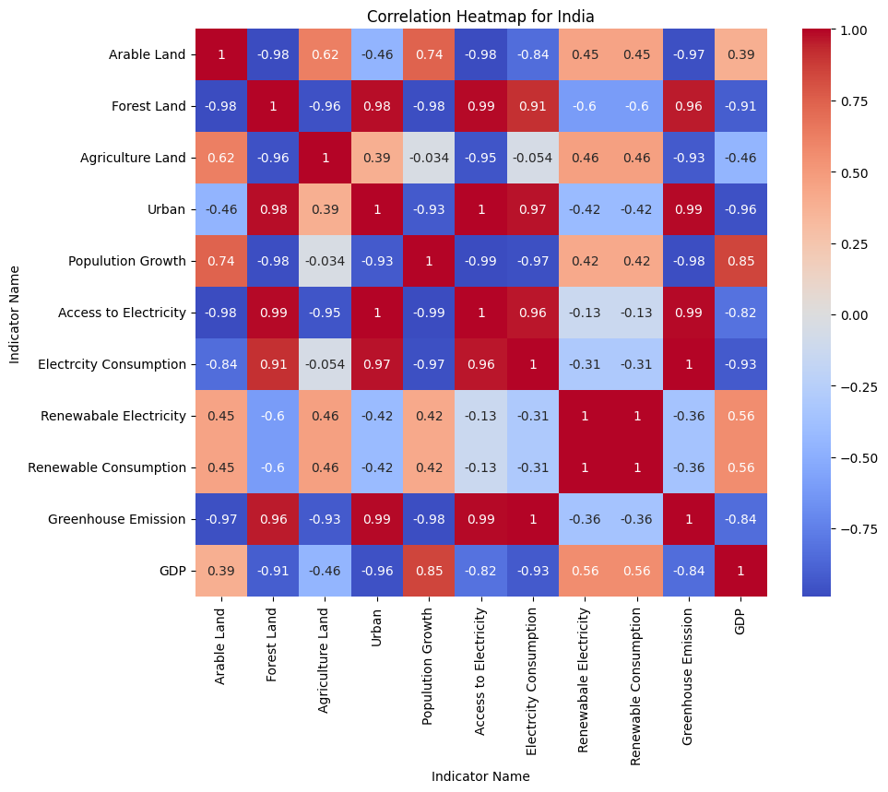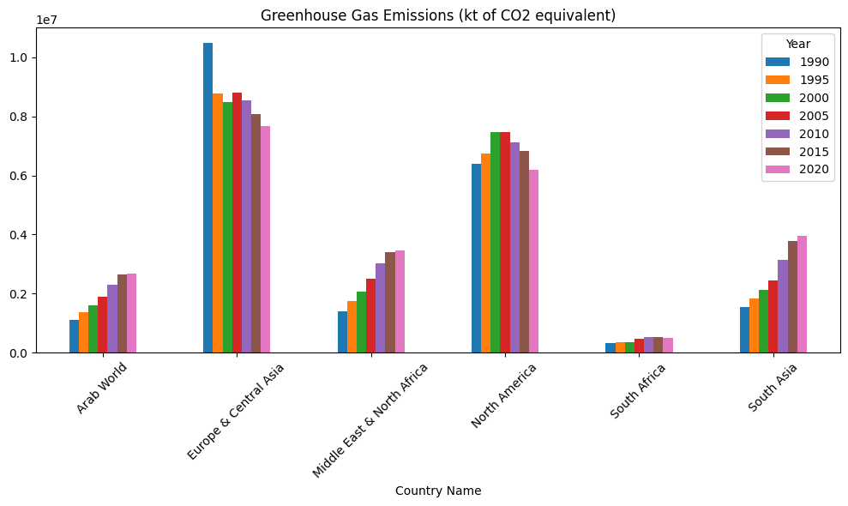

The heatmap of India shows that there is strong correlation between urban population and access to electricity, electricity consumption, and greenhouse gas emissions. The negative correlation can be seen between greenhouse gas emission and arable land. The less arable land the more will be greenhouse gases. The more population growth over the years leads to reduced access the electricity. Electricity consumption increases CO2 emission.

From the bar graph, it can be clearly seen that Europe and Central Asia are the largest emitter of greenhouse gases and impact the climate, followed by North America. But over the years these regions try to reduce the emission by the use of renewable energy sources. South Africa has less emission. The greenhouse gas emission for other regions increases over the period of time. These regions should take proper measures to control the factors that negatively impact our environment.